**DAILY ONLINE ACTIVITIES SUMMARY**

|  |  |  |  |  |  |  |  |  |
| --- | --- | --- | --- | --- | --- | --- | --- | --- |
| **Date:** | **21/05/202** | | | | | **Name:** | **Anjali Manohar Prabhu** | |
| **Sem & Sec** | **4th Sem Section - ‘A’** | | | | | **USN:** | **4AL18CS007** | |
| **Online Test Summary** | | | | | | | | |
| **Subject** | | **Microcontroller and Embedded System** | | | | | | |
| **Max. Marks** | | **30** | | **Score** | | | **13** | |
| **Certification Course Summary** | | | | | | | | |
| **Course** | **CLOUD FOUNDATION** | | | | | | | |
| **Certificate Provider** | | | 1. **Great Learning Academy** | | **Duration** | | | **3.5hrs** |
| **Coding Challenges** | | | | | | | | |
| **Problem Statement:** 1. Write a C program to implement STRF process scheduling  **Problem Statement:** 2. Write a C program to construct a singly linked list by removing duplicate elements in the sorted linked list  **Problem Statement:** 3. Write a C program to create sll with n elements and reserve the elements using C | | | | | | | | |
| **Status: Executed** | | | | | | | | |
| **Uploaded the report in Github** | | | | | **Yes** | | | |
| **If yes Repository name** | | | | | [**https://github.com/vinisharen/lockdown-coding**](https://github.com/vinisharen/lockdown-coding) | | | |
| **Uploaded the report in slack** | | | | | **Yes** | | | |

Online Test Details: MES test was conducted from 10:00 to 10:40 which was held on 21 may 2020. The test included MCQ question and each question consist of 1 marks and total number of questions were 30

Certification Course Details:

The foundation serves as a neutral party holding all Cloud Foundry [intellectual property](https://en.wikipedia.org/wiki/Intellectual_property). Once intellectual property is contributed to Cloud Foundry, it becomes property of the Foundation and these assets cannot be transferred to for-profit entities, as per the laws governing 501(c)(6) organizations. The Foundation holds two contributed types of intellectual property: trademarks and a copyright on the [collective work](https://en.wikipedia.org/wiki/Collective_work) of the community. It also has a license to use and re-license all code contributions, but does not own copyright on those contributions.

Snapshot: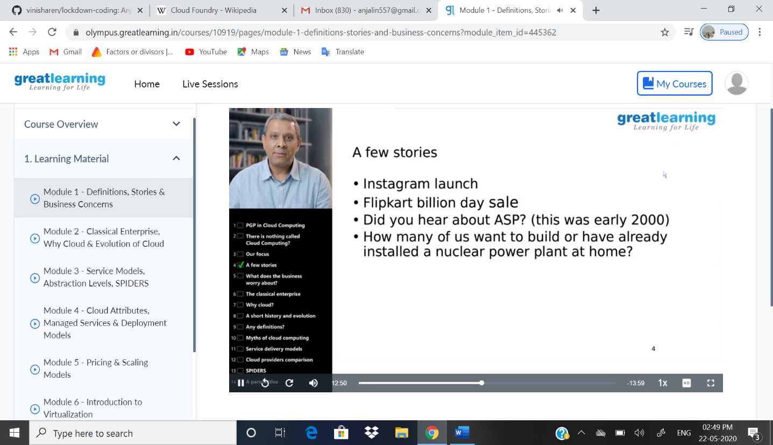

Coding Challenges Details: Problem statements: .

1. . Write a C program to implement STRF process scheduling

Solution: Uploaded in github

Snapshot: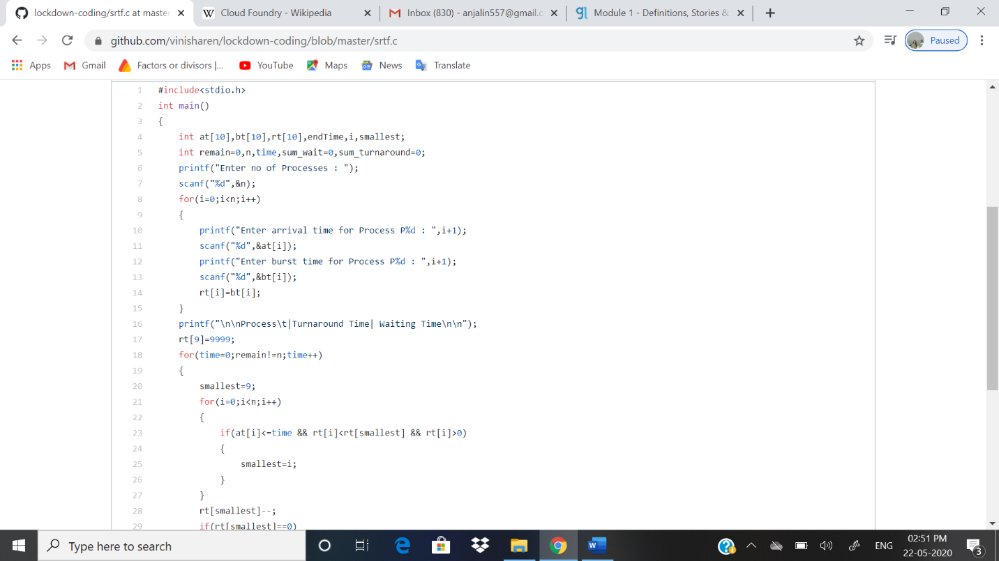

1. . Write a C program to construct a singly linked list by removing duplicate elements in the sorted linked list

Solution: Uploaded in github

Snapshot: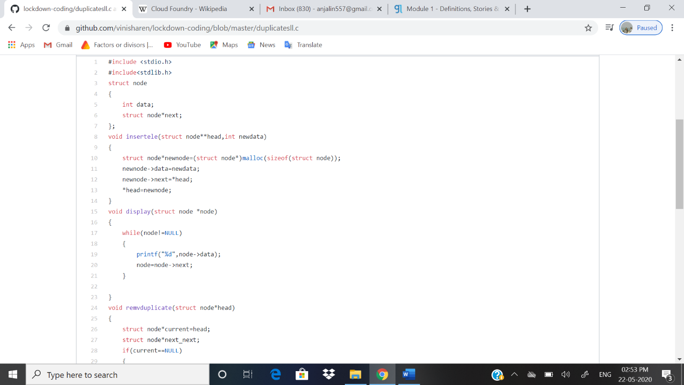

3. Write a C program to create sll with n elements and reserve the elements using C

Solution: Uploaded in github

Snapshot: 